LifeWave Vista Print Graphics

If you are wanting to have a few items from for shows, events and promotion, you can contact VistaPrint.com (set up an account if you don’t have one) and have these items downloaded directly into your account for printing.

You can edit each of them with your personal information.

Give them my name Robin Blanc Mascari and my account number
Account # 1926-8975-6095 with my email Robinsky@mac.com and you can get any of these items below that you are interested in - transferred to your account.

This will simplify not having to transfer and size artwork.

Banner and Business Card
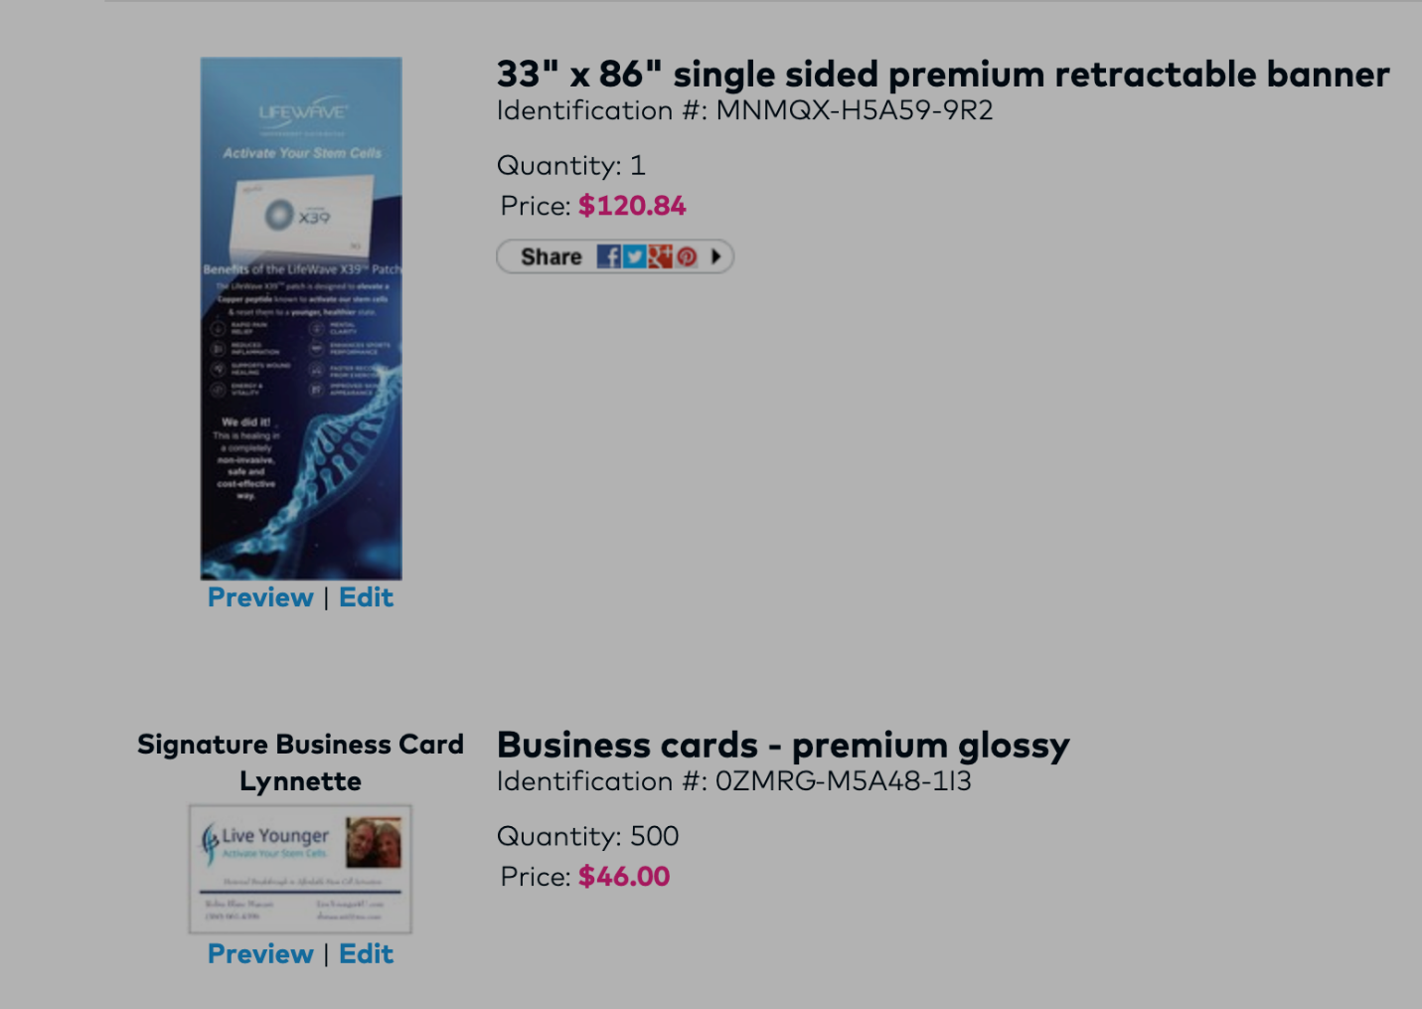

This is a small retractable table top banner that doesn’t have great quality and still works
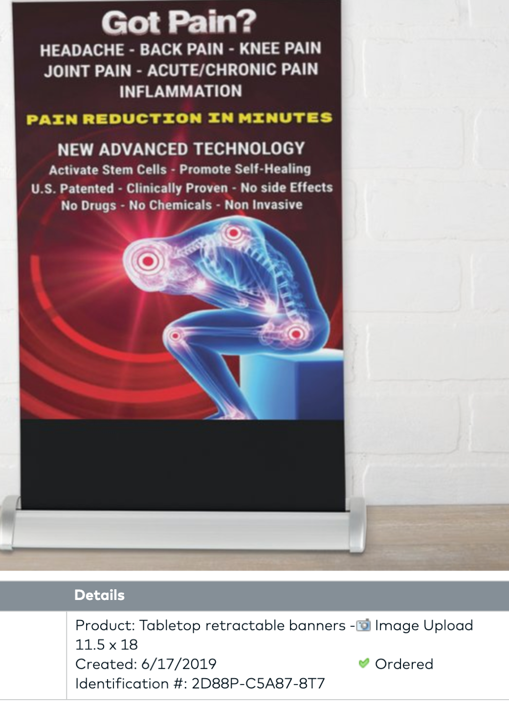
CAR MAGNET
